RKMID Android5.1平台PCBA测试说明

**1、内核配置，PCBA固件无需selinux，请关闭，对于正常固件请打开；**

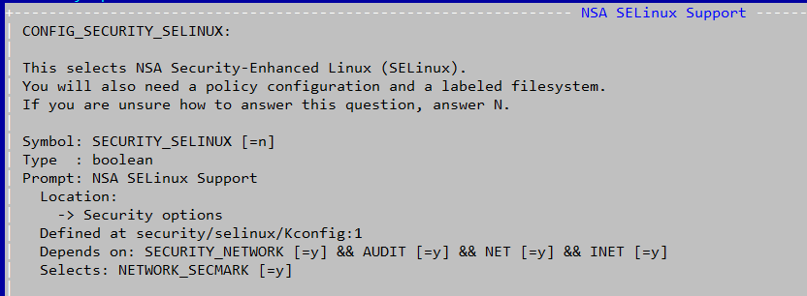

重新编译kernel，然后更新recovery的kernel。执行下面命令即可：  
cp kernel/arch/arm/boot/zImage out/target/product/**rk3288**/kernel

红色的目录需要换成你自己的编译路径；

**2、build/core/Makefile文件修改：**

--- a/core/Makefile

+++ b/core/Makefile

@@ -828,7 +828,7 @@ endif

ifneq ($(strip $(TARGET_BOARD_PLATFORM)),sofia3gr)

# Named '.dat' so we don't attempt to use imgdiff for patching it.

**-RECOVERY_RESOURCE_ZIP := $(TARGET_OUT)/etc/recovery-resource.dat**

**+#RECOVERY_RESOURCE_ZIP := $(TARGET_OUT)/etc/recovery-resource.dat**

endif

ifeq ($(TARGET_ROCKCHIP_PCBATEST),true)

@@ -904,7 +904,8 @@ $(INSTALLED_RECOVERYIMAGE_TARGET): $(MKBOOTFS) $(MKBOOTIMG) $(MINIGZIP) \

$(recovery_fstab) \

$(recovery_fstab_mtd) \

$(recovery_fstab_emmc) \

**- $(RECOVERY_INSTALL_OTA_KEYS)**

**+ $(RECOVERY_INSTALL_OTA_KEYS) \**

**+ $(pcba_core)**

@echo ----- Making recovery image ------

$(hide) rm -rf $(TARGET_RECOVERY_OUT)

$(hide) mkdir -p $(TARGET_RECOVERY_OUT)

**3、打开device/rockchip/common/BoardConfig.mk文件中的：**

diff --git a/BoardConfig.mk b/BoardConfig.mk

index 28ef7f8..85f5e64 100644

--- a/BoardConfig.mk

+++ b/BoardConfig.mk

@@ -154,7 +154,7 @@ RECOVERY_AUTO_USB_UPDATE ?= false

**-TARGET_ROCKCHIP_PCBATEST ?= false**

**+TARGET_ROCKCHIP_PCBATEST ?= true**

TARGET_RECOVERY_UI_LIB ?= librecovery_ui_$(TARGET_PRODUCT)

**4、修改external/rk-pcba-test/Android.mk**

第一处：

把mk中两处eng改为optional

-LOCAL_MODULE_TAGS := eng

+LOCAL_MODULE_TAGS := optional

第二处：

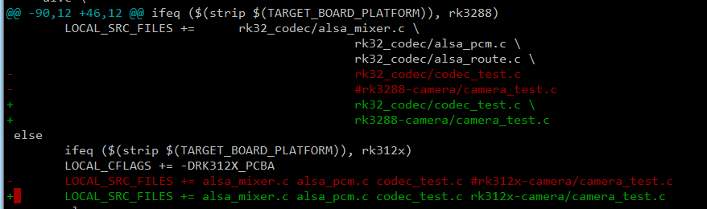

**5、对于pcba的camera：**

**3288 5.1暂时不支持，请在external/rk-pcba-test/res/test_config.cfg 关闭这项测试；**

**312x 5.1平台支持camera, 需修改如下：**

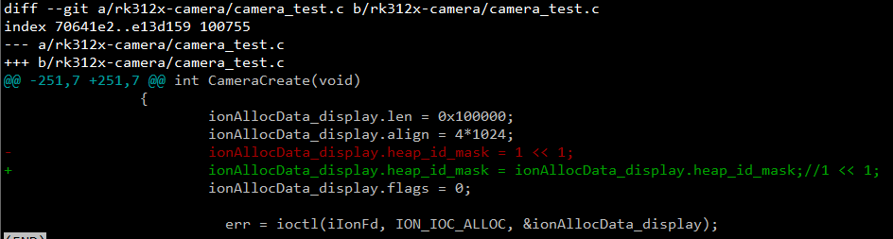

**-** ionAllocData_display.heap_id_mask = 1 << 1;

**+** ionAllocData_display.heap_id_mask = ionAllocData_display.heap_id_mask;

如果不行，换成如下修改

pcba文档的第五步这样修改下：

ionAllocData_display.heap_id_mask = 1 << 1;

改成：

ionAllocData_display.heap_id_mask = ION_HEAP(ION_CMA_HEAP_ID); //1 << 1

**6、编译**

执行make命令，编译完后请确保下面目录是否有一下文件(注意：红色目录是你们自己的目录)：

ls out/target/product/rk3288/recovery/root/sbin/目录:



ls out/target/product/rk3288/recovery/root/system/lib



如果没有的话请手动在external/rk-pcba-test/目录执行mm –B , 然后重新make即可；